Gender Conventions in Nineteenth-Century Vermont

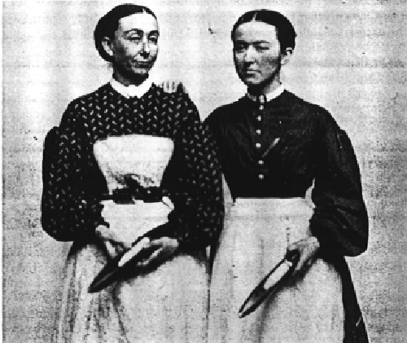

Early Nineteenth-Century Woman’s Sphere

Gender conventions, like so many other aspects of American life, changed dramatically in the nineteenth century. Developments in commerce, industry, and transportation reshaped the parameters of manhood and womanhood in the small towns and countryside of Addison County, Vermont. As men confronted an increasingly fluid, individualistic, and competitive public sphere, women and the domestic sphere came to represent moral virtue. As Nancy Cott observes, and as the experiences of women like Charity Bryant, Sylvia Drake, and Caroline and Rebecca Ford suggest, the doctrine of separate spheres afforded women a range of possibilities for public and private expression. While “piety, purity, domesticity, and submissiveness,” might have characterized a woman like Betsy Miner, young women like the Ford sisters left home to pursue factory work, while others like Charity Bryant and Sylvia Drake explored a life of mutual devotion exclusive of heterosexual marriage. Even Betsy Miner, whose letters to her mother reflect a more conventional experience of domesticity, contributed to her family’s financial enterprises in sometimes unconventional ways.

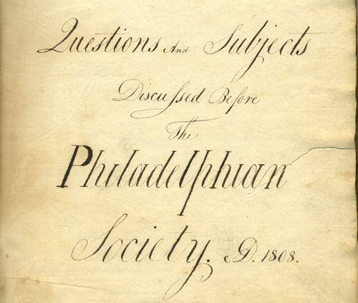

Early Nineteenth-Century Man’s Sphere

The complexity of nineteenth-century gender roles is further illustrated in the early history of Middlebury College. Prior to the Civil War, as David Stameshkin observes, religious devotion was central to the everyday experience and occupational aspirations of the men who attended Middlebury. The pious tone of the Philadelphian Society, a student debating society, reflects the broader commitment to Christian piety in the early nineteenth-century College. Many early Middlebury graduates became ministers, and some, like Pliny Fisk, sought to realize the masculine ideal of the Christian Soldier by becoming foreign missionaries. Evangelical Christianity thus remained the province of early nineteenth-century men as well as women. Missionary work was a mixed-sex affair, and the diary of Mary Elizabeth Allen Martin exemplifies the roles that women played alongside men in missionary work.

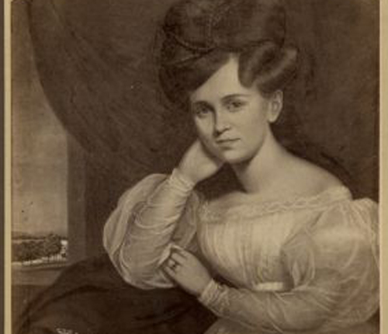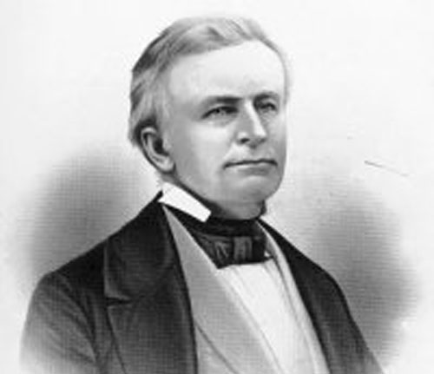

Nineteenth-Century Men and Women: Romantic and Familial Bonds

While men and women occupied separate spheres in the early and middle decades of the nineteenth century, those spheres overlapped in important ways. The heterosocial preoccupations of schoolteacher and diarist Francis Paine and the romantic correspondence of Emma Hart Seymour and Philip Battell offer two illustrations of men’s and women’s fascination with each other. Paine’s appreciation for the physical charms of his female students, as well as his close relationships with female family members, are documented in his diary of the 1840s. Seymour and Battell’s intimate correspondence, in which they communicated mutual devotion but also anxiety, reflects the value nineteenth-century men and women placed on romantic love and affectionate companionship.

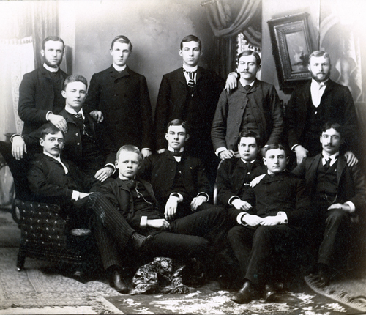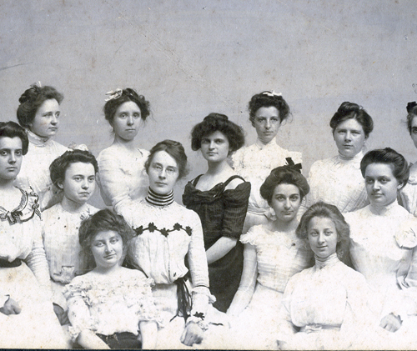

The Late Nineteenth Century: Shared School and Leisure, Separate Work

The late nineteenth century brought new shifts in middle-class gender relationships, as the advent of coeducation at Middlebury College and the emergence of college fraternities and sororities reveals. Piety and domesticity mattered less to young men and women in the final decades of the nineteenth century, as mixed-sex entertainment and commercialized leisure gained prominence. Religion, which had been integral to early nineteenth century ideals of masculinity and femininity, became increasingly marginal. By 1900, the single-sex worlds of men and women had been displaced by the emergence of a heterosocial culture. Yet at the same time, the work lives of men and women remained largely separate, as men dominated most public and professional affairs, and women continued to labor primarily within the home.

