Tip Top Weekly:
An Ideal Publication for the American Youth

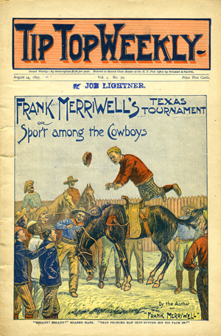 | Billed as “An Ideal Publication for the American Youth,” Tip Top Weekly featured the adventures of prep-school- and Yale-educated Frank Merriwell and his younger brother, Dick. The weekly began publication in 1896 under the auspices of Street and Smith, a New York firm that published several dime novel series. Running for more than 800 issues, Tip Top Weekly exemplifies ideals of athletic, clean-cut young manhood which were also being touted by Theodore Roosevelt, G. Stanley Hall, and others at the turn of the twentieth century.

The Buffalo Bill Stories: A Weekly Publication Devoted to Border Life
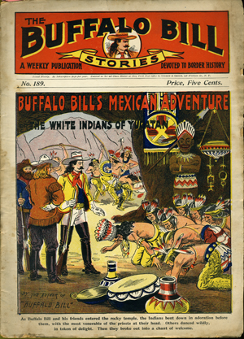 | The Buffalo Bill Stories, published by the New York firm Street and Smith from 1906 to 1910, capitalized on the American boys’ fascination with western adventure stories. Many issues focused on historical incidents in the life of the Colonel William Cody, who gained fame as an army scout and buffalo hunter before becoming the star of his own Wild West Show. Claiming greater authenticity than other dime novel westerns, some issues of The Buffalo Bill Stories contained the following publisher’s note:  Beware of Wild West imitations of the Buffalo Bill Stories. They are about fictitious characters. The Buffalo Bill weekly is the only weekly containing the adventures of Buffalo Bill, (Col. W.F. Cody), who is known all over the world as the king of scouts.
Work and Win:
An Interesting Weekly for Young America
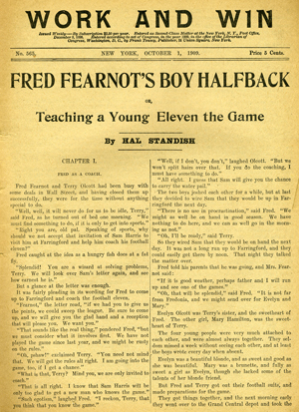 | Published in New York by Frank Tousey, Work and Win was a long-lived series featuring the adventures of Fred Fearnot, an adventurous youth often accompanied by his best friend, Terry, and his girlfriend, Evelyn. The series ran from 1893 to 1925, and included over a thousand issues.

