The Value Equation:
Value Chain Management, Collaboration and the Internet

Andrew White, Logility, Inc.

Introduction

Even if the software package you implement in the next 12 months to manage your business is called Enterprise Resource Planning (ERP) or Advanced Planning and Scheduling (ASP), one thing you know for sure - the competition is doing something else. Eight years ago the message from the top was along the lines of "logistics and logistics management". With maturity the rallying cry has shifted to “Supply Chain Management” (SCM), which once described the "flow of products and information between customer and supplier". The consultants of the day informed us that SCM was the new wave, the next “big thing”. But in order to survive today, it does no one any good to mimic, copy or follow the enemy. Repeating what everyone else does ensures you remain in your place in the pecking order. With the success of numerous ERP vendors and the un-differentiated and homogenous attitude to competitive weapons, the time is ripe for a sea change.

This paper will explain why the value provided by ERP has already expired and passed its sell by date. This paper will detail the purpose of ERP and how it has reached the end of it’s life cycle as a strategic competitive weapon, and how APS tools are evolving to provide the most strategic of tools. Further, we shall explain away the last-ditch attempt by the ERP vendors to usurp the APS vendors and their efforts through the adoption of the new “best in class” business processes, that of Collaboration.

From ERP to SCM and then…

In the early nineties the phrase Supply Chain Management (SCM) came into vogue. The original concept of SCM was the "elimination and removal of barriers between trading partners" in order to facilitate the synchronization of information between them. This new movement appeared to capture the imagination of senior executives but it also showed that ERP was in fact incomplete. Unfortunately the very underlying tools in ERP did little to address the "elimination of the barriers between trading partners" since all the tools were focused on the internals of the organization Since ERP remained principally focused on the organization, the suppliers of ERP tools decided to "own" the concept of SCM in order to leverage the vision it offered - and to extend the life of ERP tools by appearing to offer such solutions.

Over the last 20 or so years most organizations have spent many millions of dollars implementing and re-implementing ERP systems. Today ERP is the most prevalent software tool deployed. It is used successfully to standardize on the financial and transactional processing needs of the organization. The epitome of ERP is SAP - another 3-letter acronym. SAP is the largest, most successful ERP tool provider ever.
But what companies have not focused on much is the information flow between and across trading partners. ERP is internally focused and ensures all departments talk the same language. But what about their customers or suppliers? What ensures that all parties talk the same language there? ERP does not cross inter-company boundaries so it cannot help - and so we come to Advanced Planning and Scheduling, or APS. Another acronym we know, but APS tools providers represent those smaller vendors who have been focused on the planning component of an organization. ERP is synonymous with execution, and APS is synonymous with planning - the provision for the materials and processes to meet the needs of the customer when an order arrives. In other words, planning requires the anticipation of the customer’s needs, the anticipated needs of one's own organization, and those of the supplier base. Planning, or APS therefore typically includes such activities as Demand Forecasting. By forecasting a customer’s demand accurately, an organization can take steps to go beyond simple ERP-focused asset efficiencies and move to exploiting asset effectiveness. ERP is all about efficiency; APS is all about effectiveness.

Even though ERP is an evolved and still evolving structure it is focused on transactions. Each and every company today still responds to the same transaction as they always have: a customer order. We have certainly optimized the communication of the Customer Order - we perhaps might use Electronic Data Interchange, or EDI to share the data with our suppliers. But the nature of the transaction has not changed very much over the years.

Herald the Internet

It would seem that after 36 months of hype, press-grabbing headlines and the continuous marketing efforts of various companies and industry segments, most business people agree that the Internet is of strategic importance when it comes to Supply Chain Management, or Value Chain Management as it has become known.

Like the definition of Supply Chain Management, the Internet has suffered at the hands of the intelligent. Three years ago we focused on company home pages. All our companies were told that we had to have a corporate presence on the 'net if we were to survive. So we all rushed out and overnight virtually created a multi-billion dollar market called web page design and hosting. And today most companies have a web site - and most companies are not real sure what the point is. Simple brochure “netware” has since (thankfully) happened easily enough.
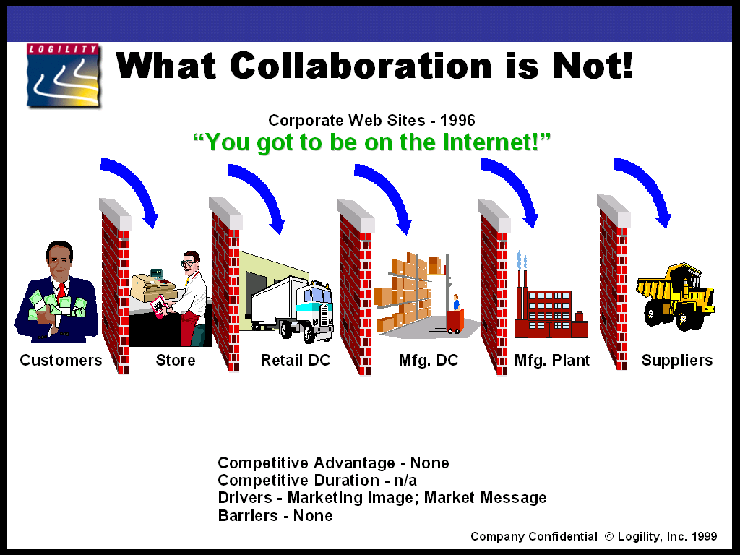

All companies can and are creating web sites in minutes. The advantage today is nominal – and perhaps we should stop spending any more money talking about it since it is so basic.

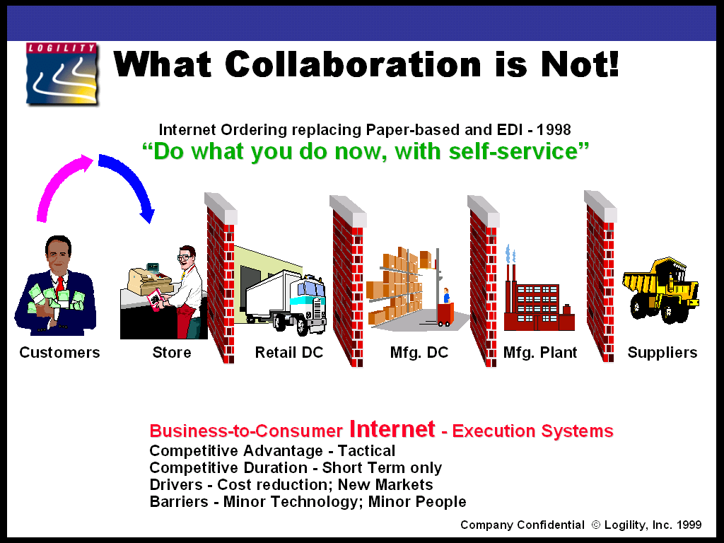

If one looks at Dell Online or Amazon.com one can appreciate the value of using the Internet to extend the ERP business-to-consumer processes. In both cases the transactions are the same as always - customers placing orders. Using the Internet means that the orders are placed more quickly and "at one's leisure" but the transactions are still the same - customer orders. For Dell and Amazon, these processes are strategic in importance as they offer to these respective companies an ability to compete on a different level to their competitors. However, because the technology is not in itself a barrier, and the reengineering of the processes is minimal because the "nature of the transaction" has not changed, all of their competitors will replicate the process in a very short time. Therefore the on-line order processing fad of today will be short lived. Inside 18 months most companies could deploy the technology. It is in truth a tactical advantage at best. What does change the nature of the transaction between trading partners is "collaboration".

So we may think that Dell Online and Amazon.com have "proven" that e-commerce pays! Wrong again. It is far too easy to move revenue generation from the retail store to the e-store: reducing direct costs is the main driver; opening up to new markets is a minor driver. This tactical move has actually proven extremely successful for the first few companies in each market, even though it is technically simple and does not require much business process reengineering. Before the millennium is reached, all-important companies who sell to consumers will be selling to consumers via the Internet – or they won’t be important anymore. The key point is that the nature of the transaction has remained the same – it is a customer order now over the Internet that replaces a Customer Order in the store.

However, lucrative opportunities exist to increase exposure to more buyers and reduce investment in storefronts and sales people. But the lead provided is short. In summary, this is “business as usual – only self service”. So I guess the public benefits! (That makes a change.)?

…From SCM to Collaboration – the Fatal Conceit

The most insidious development to take place in the last 6 months is the onslaught by leading ERP vendors to undermine a new concept taking shape in the market. They are effectively trying to strangle at birth what could be and should be the most significant event in the last 20 years of Materials Management: true collaboration over the Internet.

As ERP stole the hot new idea in the early nineties (SCM) so too will the newly painted ERP/SCM vendors steal the hot new phrase called "collaboration." Even today we can see in the majority of industry press the words supply chain and collaboration in every story. If you need financial systems, order processing or manufacturing systems all of a sudden you are buying into the collaborative movement. Unfortunately, simply putting these activities over the Internet does not "change the nature of the relationship between trading partners" and this is the qualification to determine true collaboration as opposed to some fancy marketing hype.

What is also important to realize is that collaboration is not only dedicated to trading partners but to internal users as well. Once upon a time the concept of "one number planning" was conceived to represent the objective of synchronizing all the facets of an organization in order to focus their efforts in a similar direction. We can all remember the days when each department had objectives and it was assumed that if all departments met their objectives so too would the organization. However, through painful experience we learned that this was not the case - the sum of the parts instead brought down the whole. One number planning is an ideal to ensure all priorities and objectives are reconciled inside the company, so that manufacturing, distribution, finance, sales and marketing all are "singing from the same hymn book." So collaboration is as important inside the four walls of the enterprise as it is beyond the four walls. Indeed, many would argue that before one attempts to collaborate with one's trading partners one ought to ensure the successful and complete collaboration inside the company!

"Doing what you do now, only faster!" sums up the results you can expect of “doing ERP over the Internet”. Has anyone asked himself or herself “what value do I bring to my Customer or Supplier by giving them access over the Internet to the same complex screens I now use to do business internally?” The point is – NONE. There is no re-engineering, little evolution, and to be quite frank, everyone can do this rather easily. In fact the smaller ERP companies can adopt this technology faster than the larger ones!

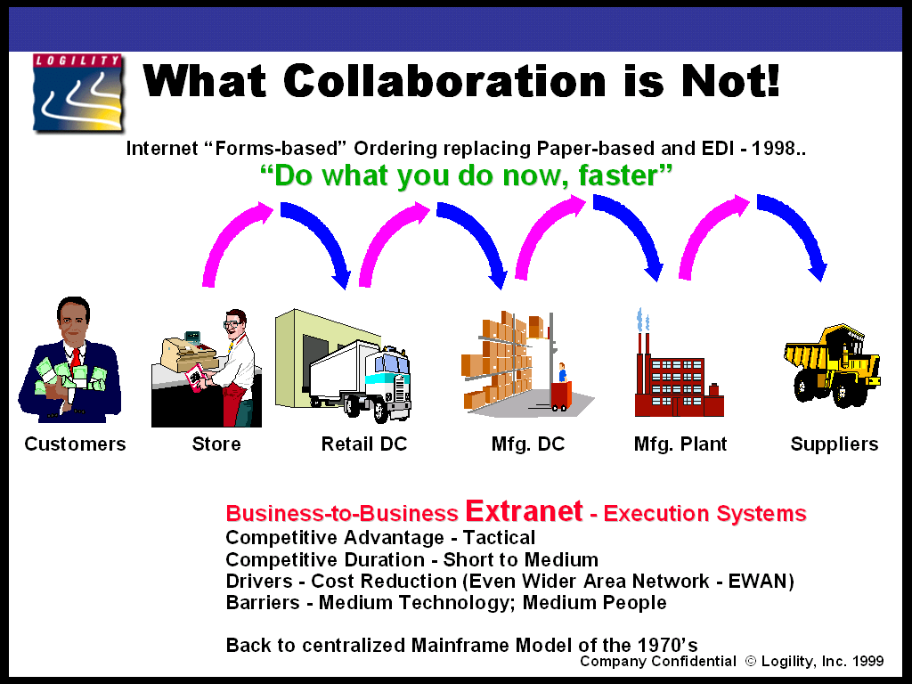

SAP and all other ERP players are asking the market to spend millions of dollars to devolve true ERP functionality over the Internet. "Business to business" transactions are the key, however, when "execution" versus "Planning" is at stake. SAP, Oracle and so on are transaction or ERP vendors that own the corporate database - they track and measure the movement and accounting of product. ERP vendors do not plan for the most effective supply to meet the demand, despite what their literature suggests. Consequently, ERP vendors are trying to "own" the Internet for ERP by providing forms-based screens - Order Processing to a sales rep using a form remotely. This is hardly competitive - yet the market sees it as the combination of the hot "Internet" concept and the hot "SCM/ERP" message.

For example, ERP over the Internet as it has evolved:
- SAP, Oracle, PeopleSoft: Forms-based ERP (no logic required on the client - mainframe model returns; centralized control and (NC) light client;
- SAP "web enabled" R/3 - which is basically an Even Wider Area Network (EWAN) and nothing more (still have training, software distribution and "do what I do now faster" characteristics);
- PeopleSoft introduced an email based collaborative tool – a cheap trick - we all had 'date-time stamped' email for several years prior anyway’
- Oracle followed SAP;
- Baan and q.a.d. followed all the others;

So in summary, ERP over the Internet is “Nothing New so far.... just more of what we do now, only a little faster.... perhaps”.

True Collaboration – Before the Storm

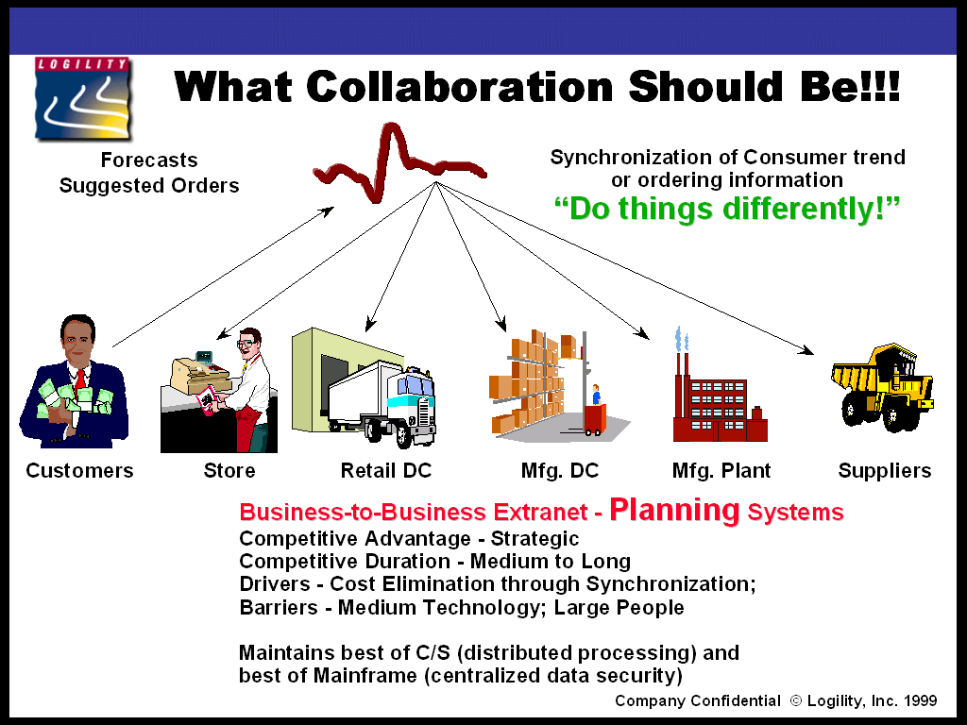

Before the ERP vendors finally get hold of the throat of collaboration, this next section will attempt to describe what the potential is. By the time you read this article, you might have struggled to find an ERP vendor that markets a collaborative tool that supports this concept.

The original vision of SCM was the “elimination of barriers between trading partners”. This concept has been re-launched under the herald of Collaboration. If one takes a short-term change in consumer demand and imagines what takes place today in a typical value chain, one can determine the impact of change necessary to achieve true collaboration. Today, a change in consumer demand can trip a store level withdrawal from a retail Distribution Center. This in turn could trip a Re Order point at the DC to generate Replenishment from the Wholesaler. This in turn could cause the manufacturer to re-run or reschedule production, which in itself could cause the raw material suppliers to increase output to protect against such variations. In fact every layer of the value chain so described here maintains a series of buffer inventories to protect themselves against changes in demand and supply. The great unknown is the primary reason for this safety stock.

If, as is likely, the consumer demand change is short lived and returns to normal, the trap has yet been sprung. The glut of inventory makes its way through the value chain until it hits a contractual agreement that provides a way out for the buyer – and a particular supplier in the value chain has to swallow some costs. They in turn gradually wise up and modify their contracts with their suppliers to pass on some of this cost, and so on. This behavior is nothing like that of a really efficient and effective value chain.

The potential of SCM (originally) and now Internet-based Collaborative planning is that consumer behavior could (a big “could”) be communicated, “as it occurs” with multiple levels of the value chain (or trading partners) so as to make public the interpretation of the change in pattern. Instead of being lost in the placement of an order, which disguises the nature of the original demand, the wholesaler and manufacturer could “collaborate” on the interpretation of the change in demand. They can agree, for example, that this was indeed an aberration and thus prevent any costly build-up of inventory. If they collectively agreed that the demand change was real, they would collectively ramp up supply – across the board – without any locally harmful effects.

The key requirements here are: Real-time, Global, Secure and Simultaneous communication.

- Real-time, because if the information is old it is worthless and you might as well wait for the Re Order point replenishment and build-up the inventory.
- Global, since this is not a US phenomenon – it is for whomever stamps their leadership role in any given value chain first.
- Secure as this is required if sufficient trust is to be established across multiple trading partners’
- Simultaneous for the same reason. The information needs to be shared between numerous interested parties at the same time – else we would be modeling the current “time phased” value chain instead of the new “time compressed” value chain.

As can be seen, this “changes the nature of the relationship and hence transaction” between trading partners. Instead of buyer/seller relationships we have collaborative relationships – instead of customer and purchase orders we have collaborative forecasts and replenishment orders. The relative importance of ERP is greatly changed. Through effective collaborative forecasting in anticipation of the demand, the Order Processing step is virtually eliminated through mass automation. This key point helps to explain why ERP vendors are keen to “own” the word – so that they can steer it in order to save their skins!

CPFR: Collaborative Planning, Forecasting and Replenishment

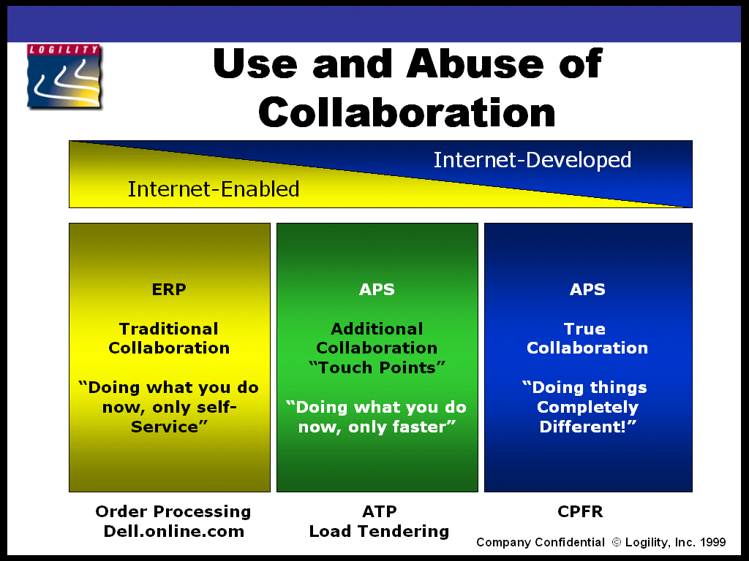

The above graphic represents the latest evolution or “paradigm” of collaboration – that being CPFR, or Collaborative Planning, Forecasting and Replenishment. This is a new initiative being stewarded by the VICS Organization through a committee. CPFR is a business model that facilitates the complete re-engineering of the nature and hence transaction between trading partners. CPFR is not “internet-enabling EDI transactions”. CPFR is not about “dynamic trade between companies and consumers”. Both of these points are “doing what I have always done, only faster and/or self service”. CPFR is all about doing things differently. It is the newest, freshest most important event to hit the business world since EDI and ERP in their time.

The facts are that today most trading partner relationships respond to customer orders. As demand for a product changes, so a retailer replenishes the store and may trigger a replenishment rule at the local Distribution Center. From here, a manufacturer would plan to replenish the DC in a “vendor managed” process. The manufacturer in turn will place orders on the supplier and so the cycle is repeated. The weakness, as we know, is that each layer or tier of the value chain has to maintain inventory or lead time to protect themselves from those demand (and supply) variances. To help make this process more efficient and effective, companies forecast those needs (demand) and plan inventory service levels around the variances. Forecasting those customer requirements is difficult. One leading-edge model, CPFR, suggests that accuracies in the forecast can be improved by getting the customer to participate in the calculation of the forecast.

The history is that computer software is used to compare historical trends and generate a forward looking forecast based on those trends. Users with additional information, revise the statistical forecast, with a view to improving the accuracy. CPFR says that the customer ought to participate in the process and even contribute to the number generation in the first place. After all, both trading partners are forecasting – the retailer is planning supply and manufacturer is planning demand – and so on! The retailer knows more about their business then the supplier and vice versa!

Competition in the business world today is still focused on company versus company. CPFR is the first real standards-based initiative that re-aligns the competitive boundary along the lines of supply chain versus supply chain. For example, Wal*Mart and Kmart are keen supporters of this initiative. Indeed, Wal*Mart played a pivotal role in the initial drivers of CPFR. As a parallel, Logility was also an early leader in this market since Heineken USA was the worlds’ first LIVE user of such technology with their 450 customers in North America.

The Darwinian Effect

What is strange about CPFR is that Wal*Mart and Kmart and their mutual competitors are “partnering” to make CPFR real. What is also strange is that all the primary manufacturers are also “partnering” to make CPFR real. The past provided for a manufacturer to implement Vendor Managed Inventory in order to steal a competitive advantage over their peers. The same was true of the retailers’ view of Vendor Managed Inventory. With CPFR, there is much less drive for such “selfish” or Darwinian advantages. How is possible and is it likely to last?

The answer is a resounding “yes”.

As we all know from college, Darwin talks about the survival of the fittest. With CPFR the realization is that the definition of “the fittest” no linger stops at the factory gates or the single enterprise – even if a global concern. The message here is that competition for the millennium is also at the supply chain level, and in time will be focused singly on this. CPFR will work for several reasons. The customer (retailers) assures a better service level to their customers (consumers) from a higher in-stock service level and they also obtain a better service level themselves from the suppliers (manufacturers). From the suppliers’ viewpoint, the forecast is more accurate which leads to a more stable demand plan that leads to a more stable manufacturing plan. This in turn leads to less inventory, more revenue through the collaborating channel and therefore higher profits all round.

Redrawing of Competitive Boundaries

The key here is that true collaboration “changes the transaction and hence the nature of the relationship between trading partners”. CPFR is today the best example of a true collaborative-focused approach. Remote or inter-based (distributed) Available to Promise (ATP) is an example of collaboration that fails to “change the transaction and hence the nature of the relationship”.

CPFR is forcing companies to recognize that the competitive boundaries are being redrawn. It’s not that companies have any choice; CPFR is coming big time! All the previous business initiatives, including MRP, MRP II, DRP, OPT, JIT and VMI were not focused on the trading partner relationship. Even that old favorite, ERP, was not focused on this. Only CPFR is focused. Therefore CPFR is today the most important industry movement focused on true collaboration. Over the next couple of years, numerous retailers, manufacturers, suppliers across all industries will subscribe to CPFR business models. VMI and all the other related “continuous replenishment” strategies will evolve to CPFR-type models.

And even though CPFR is seen today as a consumer goods and retail focused initiative, there are numerous examples of other industry groups – several international, that are duplicating these earnest efforts. There are formal and informal groups from the Automotive, Apparel, and High Technology segments that are meeting to “collaborate” on new, generally Internet-based business processes. RossettaNet is a group of High Technology companies such as Microsoft, Intel and IBM that provides for a network of relationships to better synchronize each other’s participation in the market. This group focused on “planning” and “execution” processes. The “process” element is a replication of the CPFR standards. In fact the CPFR movement is far ahead of any other movement for true collaborative planning – here in the US and in Europe. Any other segment would do well to review the materials produced by this group to prevent the reinvention of the proverbial wheel. Information can be found at www.cpfr.org.

Summary

The ERP vendors have a potentially significant competitive advantage for the time being, as so few organizations understand what "planning" is anyway. So to design and implement ERP transactions for the Internet simply extends the competitive advantage over those few companies that understand "planning” versus "execution".

Most critical factor to successful collaboration is not the technical barriers but rather the people barrier. The original definition of SCM 5 years ago was the elimination of "barriers" between multiple layers of the "supply chain". This however required customers and suppliers to operate together along new vertical relationships rather then the traditional horizontal 'competitive' layers that everyone had become used to. So SCM flagged in terms of actualization. Then ERP stagnated for ideas and SCM continued to grow - and so SAP and Oracle decided to move into the so-called "new market" of Supply Chain. Today the lines between ERP and SCM are blurred. “Collaborative planning” is taking shape as the next “big thing”. However, we need to be very careful how we describe collaboration, as it too will soon be misunderstood. True collaboration requires a strategic change in the nature of the relationship and the transactions between trading partners. Dell Online and Amazon.com are short-term competitive advantage weapons that touch collaboration but do not conform to the true meaning because they use the same transaction with only a little twist on the relationship side.

Simply putting Order Processing, Purchasing or any financial applications over the Internet (like the leading ERP vendors suggest) does nothing for true collaboration. This is because neither the nature of the relationship or transaction is changed. This offers very short-term advantage to those few that adopt it. It is likely that over the next few years many companies will adopt this technology and not realize any significant benefits – because it does not conform to true collaboration.

