
The Rise and Fall of the Trading Exchange
“shhh – don’t tell my competitor!”

By Andrew G. White
Logility, Inc.

Contents:

Introduction
Definition of a Trading Exchange/Net Market
Evolution of the Trading Exchange/Net Market
Common Traits of a Trading Exchange/Net Market
- Many to Many, Public Versus Many to One, Private
- Price is the Primary Decision Driver
- Transaction is the Focus, Not the Forecast (which derives the transaction)
- Products are Not Differentiated
- Fulfillment is Homogenous
- Continuous Innovation Versus Discontinuous Innovation
- Self-service Versus Exception-based
- B2B versus B2C
Internet Commerce Continuum
The Future for the Trading Exchanges Business Model

Introduction

Practically overnight the Internet has created zillions of net worth in start-ups and not so new “portal” companies that provide Internet-based, many-to-many Trading Exchanges where buyers and sellers congregate to transact business. But the hype that these portals have attracted to date far outweighs the real usefulness of such portals. The bottom line: In less than 12 months the Internet and its hyperspeed consumption and adaptation of business processes has claimed yet another victim through the birth, growth, short-spaced maturing and death of the Trading Exchange as we know it!

As a result of all the hype surrounding Trading Exchanges over the past 12 months, too many people have been applying portal technology to economic models that do not make sense. Many companies that have actually implemented or thought through the Trading Exchange model have seen or will soon see the light -- and in it the problems inherent in the Trading Exchange business model. Most software providers, consultants and experts, however, are still far from this realization.

Today, a new model for business-to-business (B2B) e-commerce exists that has already relegated the Trading Exchange to the sidelines. This new model is known as Collaborative Communities. To understand why Collaborative Communities offer a much better solution for companies taking their business to the Internet, let’s take a look at why the Trading Exchange business model will lose favor and potentially be the first -- and biggest -- Internet-created bubble to burst.

Definition of a Trading Exchange/Net Market

A Trading Exchange is a centralized portal that can do several things. In some cases these Exchanges may be described as “vertical” when they are used by a specific industry (e.g., chemicals, plastics, food & beverage, electronics) to focus on one location in which to transact business. Another model is referred to as a horizontal portal where, for example, a given process such as procurement or transportation is transacted for several industry segments that share common traits. In both cases, the very feature that made portals readily understandable and thus attractive to investors is the same reason why they are overvalued. The reason for this is that the definition of “portal” is about to change to incorporate what we call a Collaborative Community. Portals, without the benefit of Collaboration, are merely Web sites where companies go to transact routine business. A portal powered only by a Trading Exchange is simply transacting the same buying and selling processes common to business. Of course the portal handles these processes faster and better than other methods, but it is still not exploiting the true power of the Internet to develop new processes. Because of this, the Trading Exchange will not be the “end game” for all transactions, but rather the secondary business model used primarily for low-value transactions while Collaborative Communities replace Trading Exchanges for the bulk of B2B commerce.

If Adam Smith were alive today he would suggest that an Internet portal is the perfect technological solution to perfect competition. Here’s why I believe this: A Trading Exchange is, in essence, a real-time, open marketplace where a buyer can evaluate all the potential suppliers for a particular product or service. The Internet version of the Trading Exchange is the epitome or ultimate exchange in classical economic theory that describes “perfect competition.”

“The unique feature of a B2B Exchange is that it brings multiple buyers and sellers together (in a virtual sense) in one central market space and enables them to buy and sell from each other at a dynamic price which is determined [at a moment in time] in accordance with the rules of the exchange.”

B2B Exchanges: The Killer Application in the Business-to-Business Internet Revolution,
A.Scully, W.Woods, ISI 1999

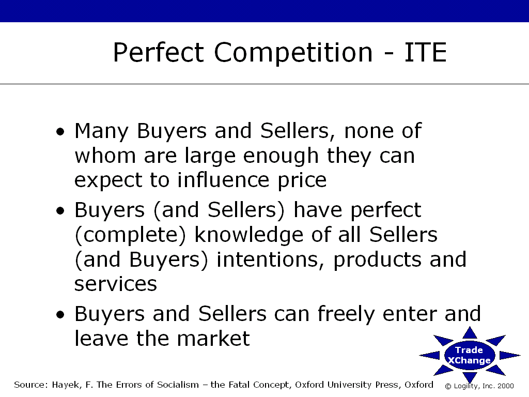

Figure 1: The description of “Perfect Competition” and the framework for an Independent Trading Exchange.

Another confusing issue surrounding Trading Exchanges is the various terms used to describe them. Being creative, many companies have already created numerous names that describe basically the same thing. Here are some of the names that are used:
- Independent Trading Exchange, ITE
- Private Trading Exchange, PTE
- Virtual Trading Exchange, VTE
- Virtual Trading Network, VTN
- Trusted Digital Marketplace, TDM
- Net Market (place)
- Digital Exchange
- Trading Hub or e-Hub
And even more marketing hype is being employed through the widespread use of the now infamous “e” or “i” extension.

The most interestingly named group has to be those providers who call themselves Trusted Digital Marketplaces. I am not sure why they would emphasize the word “trusted,” but I have to assume it is to differentiate themselves from those other “untrusted” digital marketplaces.

Evolution of the Trading Exchange Market

It is worth noting, before we go any further, that Trading Exchanges are not new. In feudal times, when sellers of pottery and clothes gathered at the center of the village they were congregating in a market. The marketplace was slow to assemble, physically bound, had high costs or barriers of entry (you had to go there), and buyers who browsed did not have all the information about all the various sellers on hand at a given time (i.e., they could not be in more than one place or negotiate with more than one seller at the same time).

As Internet Trading Exchanges have evolved over the last 12 months they have focused on a series of components that comprise, from the viewpoint of a single company, an overall e-Commerce strategy. So that you can have a better vantage point of the Internet Trading Exchange than that of a single company, following is an overview of the four stages of Internet Trading Exchange development as they relate to the potential benefit to be derived through ever-greater use of technology.

The First Stage
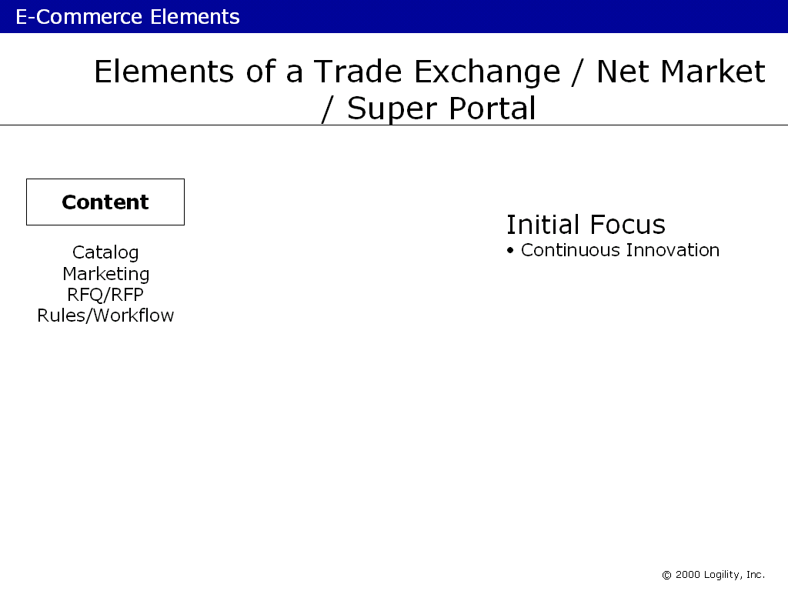

Figure 2: Initial Focus for early Trade Exchanges

Initial efforts focused on online catalogs. In essence this was a speeding up of business processes that had taken place before. Previously catalogs were paper-based, slow and costly to maintain, non-personalized, out of date, and not widely distributed or accessible. An online catalog removes many of the boundaries that limited the use of the paper-based forerunner. Despite the advantage obtained in moving catalog operations online, this move did not represent a new business process.

The Second Stage
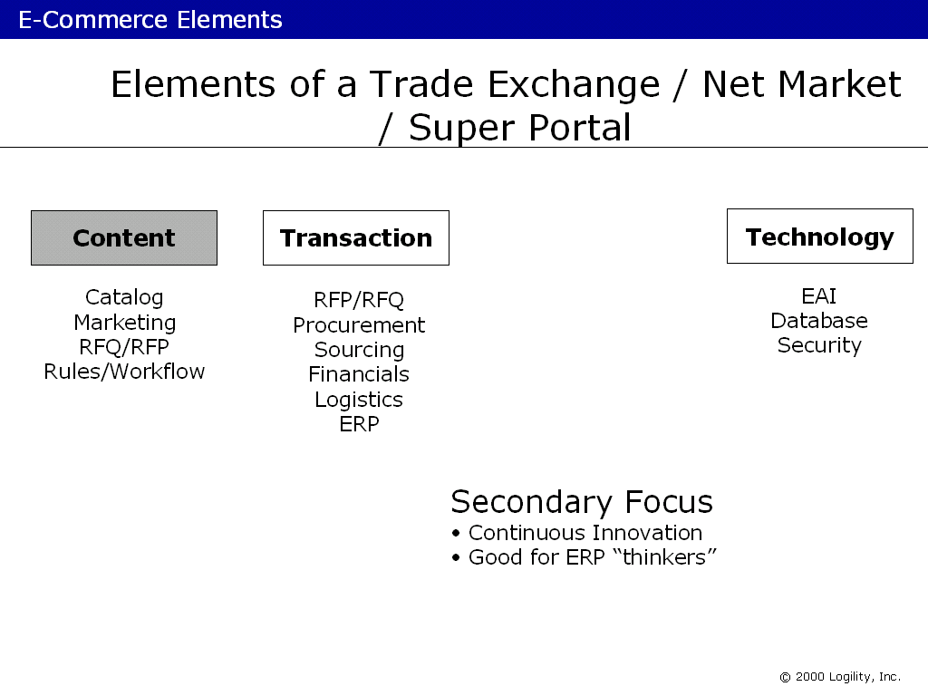
Figure 3: Secondary focus of Trading Exchanges.

Beyond the catalog wars that lasted for all of 2 months, the efforts behind Trading Exchanges moved to more valuable business processes such as how buyer and seller find each other; formalizing the bidding process; RFQ/RFP processes, etc. Many exciting developments took place that showed how real-time Internet access, security and intelligence could be deployed to make these processes more efficient. Note again, however, that these are not new process -– they are merely further examples of how the Internet can be used to make current processes very efficient; better, faster, quicker. Of course, huge savings are being realized through these efforts, but this is principally due to the Trading Exchange focus on transaction cost reduction (see Figure 4).

The Third Stage
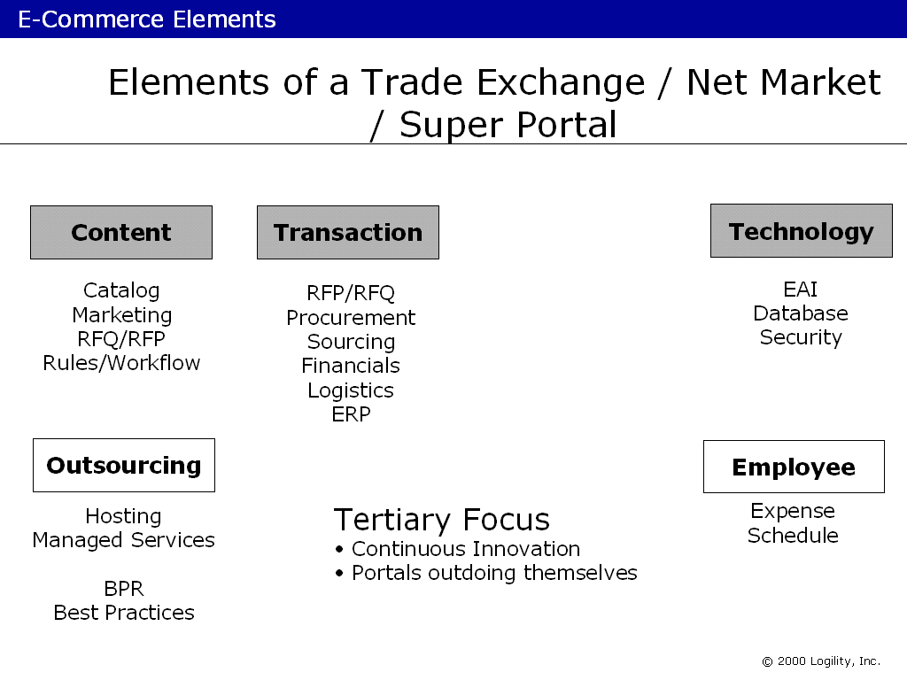
Figure 4: Exchanges looking for a place to go

Sometime in late 1999, the issue of overabundance emerged. Trading Exchanges had been popping up all over the place; two or three Exchanges could be found in every major industry segment -- making for a very confusing situation. Leading industry experts such as the GartnerGroup and AMR Research agree that for most industry segments there will likely be a “shakeout” in terms of the initial growth and subsequent consolidation of companies that offer Exchange support. But the speed at which this shakeout will take place is dependent on several issues, including:

- Overall size of the market segment
- Level of fragmentation in number of buyers and/or sellers
- Position of channel masters, if present
- Number of possible buyers and sellers
- Fluidity and visibility of information prior to the Exchange

With the overabundance of Exchanges in practically every industry segment, we have begun to see the adoption of several survival strategies. Some providers of Exchange technology, such as CommerceOne, VerticalNet and Ariba have broadened their product and technology footprint, and most have offered their products and services to additional industry segments. Several of these Exchanges are trying to further differentiate themselves by offering outsourcing options for corporate applications, thereby becoming hybrid Application Service Providers (ASPs), while others are offering supply chain and business consulting services through partnerships or acquisitions.

The Fourth Stage
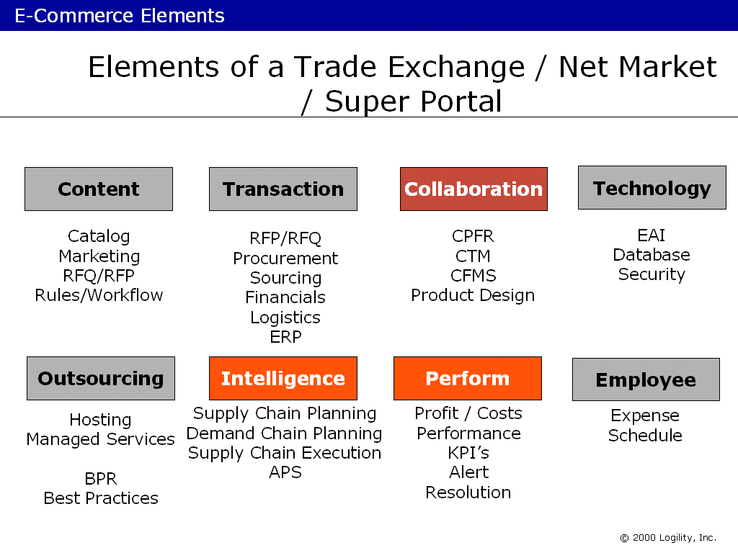

Figure 5: Comprehensive Offering

In the last 6 months or so, several Exchanges and providers of such technology have recognized that (true) collaboration is where the real value will be derived in the Digital Economy for direct material procurement and planning. This is where the next battle over mind and marketshare will take place.

In addition to traditional transaction-level support and the associated reduction in costs, it is the value derived from the ongoing relationship between businesses that will produce massive increases in customer service and revenue. This is what the Trading Exchanges will have to tap into. However, traditional “intelligent” Supply Chain and Demand Chain services already provide significant value to buyers and sellers in this area. Thus, a large potential market awaits those companies that can deliver Supply and Demand Chain services via outsourcing. After all, in the same way that “outsourcing” transaction systems is a more efficient way of doing things, so must this be true for systems that assist in legacy Supply Chain Management areas such as Demand Planning and Supply Planning.

Another interesting area evolving into a new market is that of Performance. There are a small but growing number of vendors offering solutions and services that support a number of ancillary processes, such as:

- Real-time alert notification
- Exception-based management processes
- Online data and information visibility (such as inventory, order status, etc.)
- Data mining and associated data presentation for all stakeholders
- Flexible workflow-based business process definition
- Flexible and user defined Key Performance Indicator models

These solutions are being delivered today as global solutions for a complete, end-to-end Value Chain –- often pre-packaged for a specific industry segment for fast implementation. Such packages sit on top of currently installed ERP (enterprise resource planning), APS (advanced planning and scheduling) and Supply Chain Planning and Execution systems that exist among many buyers and sellers. The services provided by these packages are often positioned as “portal” services.

Common Traits of a Trading Exchange

Now that we’ve looked into where Trading Exchanges have been and where they are now, as well as where they'll have to go to survive, let’s take an in depth look at what comprises these Exchanges so that you’ll have a better understanding of what they truly offer.

First of all, let’s list the common traits:
- Many to many
  - Anonymous sourcing (although not essential)
- Price as a key decision factor
- Transactions as the focus rather than the Forecast
- Products are not differentiated
- Fulfillment is generally homogenous
- Continuous innovation
  - Automating old business processes
  - Leveraging ERP and “traditional” use of APS
- Self-service based
- Participants are subservient to the sophistication of the software provided
- Common to B2C (business to consumer) and B2B

In examining these traits, I’ll discuss the fundamental errors and false assumptions being made by the pumped-up, hyper-inflated, over-priced supporters of such business models.

Many to Many Versus One to Many or Even One to One
The concept here is that a buyer of a given product can gain access to any number of potential suppliers via one so-called portal. This is the very essence and power of the portal concept. Before the Internet, a buyer would have to spend time and money in researching potential suppliers. Now, with the real-time and global pervasiveness of the Internet, all suppliers can now “come together” to meet the buyer more efficiently. It’s like a global e-marketplace. Wider implications can be seen in the reduction of geographical barriers that previously prevented buyers and sellers from interacting. In cyberspace there are no barriers. So information exchange is now as fast as it can be –- in principle. But the question remains: What is the important information?

In general, a buyer has a need to fulfill and he or she will go to an Exchange to source the product. The principle at work here is that the brand does not matter and that the Exchange platform acts as a framework for those suppliers to provide information to the prospective buyer. Consequently, the buyer-seller model is somewhat anonymous or transparent (or can be) until an acquisition transaction is about to take place. The critical issue here is that the Exchange model makes the transaction the central focus of its life –- whereas Collaborative Commerce makes the relationship the key, seeks to automate the creation of the transactions, and supports all planning activities leading up to the derivation of the transaction.

Price is Key Decision Driver
The principle here (and it can be argumentative to generalize this point) is that price is the main focus of the transaction. Remember, brand should not and cannot be a central consideration in an acquisition using a Trading Exchange, otherwise the buyer would transact directly with the supplier of that brand. Price is therefore the classical economic element that assists in the rational selection or acquisition. The logical sequence goes something like this: Assume a buyer wants to acquire a product. He logs onto the Web site or Exchange and acknowledges his intention to acquire. Various suppliers’ products are identified to the buyer via some catalog or rules-based process that selects candidate products. The price is the tiebreaker. This is so because other characteristics of the transaction are either not known or excluded from the transaction (see Figure 6). For example, if all buyers and sellers must use the same Customer Order Management/Purchase Order Management software tool, then this tool acts as a gatekeeper. Let’s say that the following is information that can be made available to buyers from sellers: Item Description, Price, Delivery Options and Service Agreement. If this is the case, no supplier has the freedom to further differentiate his or her product offerings. Also, the buyer is forced into making a rational decision based on these data elements. Consequently the Exchange model, when executed and deployed “perfectly,” eliminates the very basis of competition.

Each seller is highly motivated to develop unique value propositions that cannot be provided via the “all-leveling” Exchange system, thus undermining the “unique value” model and resulting in mass defection of sellers in search of other ways to compete. If sellers don’t do this, they must then reduce price in order to be perceived by the buyer as the lowest-priced alternatives. Since prices are “perfect” and visible to the buyer, he will make a rational decision and acquire the cheapest solution. Price becomes king once all other factors surrounding the product and price become non-competitive differentiators. The seller, whose margins are continuously eroded in the Exchange model, becomes more and more motivated to defect from the standard model and move to a more strategic model that focuses on relationships -- Collaborative Commerce.

Another way to look at the situation created by Internet Trading Exchanges is to see the very introduction of such portals as inserting a new company between buyer and seller. Therefore, the standard portal model presents a more complicated value chain!

The Law of Entropy states that all things tend toward chaos when left alone. In this sense, chaos represents the simplest form of structure. When man builds things, we might think that they are simple in nature, but to the universe they are complex. Why then are we allowing ourselves to make things more complex than they already are? Given a chance, entropy will force the introduction of simpler models. Darwin will even assist.

Instead of allowing these laws of nature to take place, we should be finding ways to truly simplify processes through Collaborative Commerce. With Collaborative Commerce there is no requirement for a middleman.

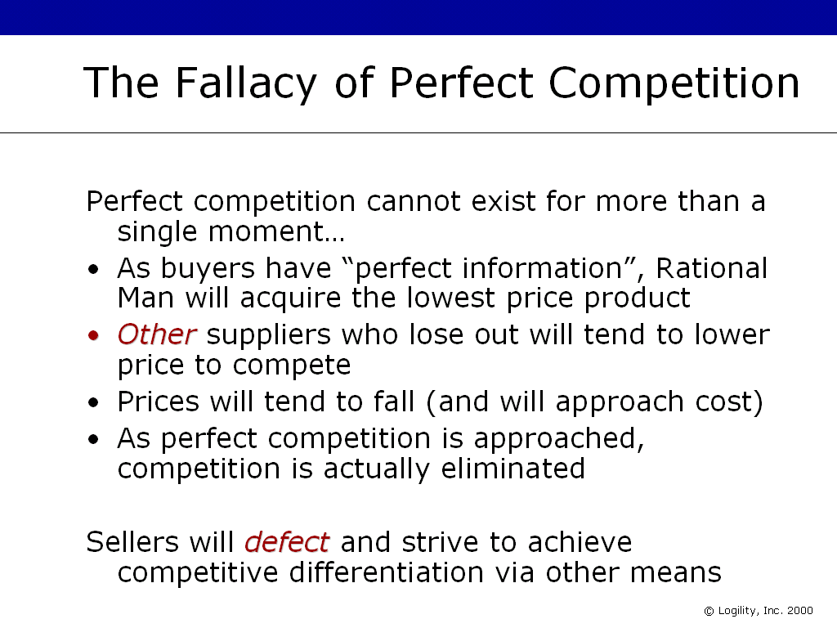
Figure 6: The Fallacy of Perfect Competition

Transactions Are the Focus, Not Forecasts (which generate the transactions)
In both vertical and horizontal Exchange models, the typical focus is on the “customer order” or the transaction itself. For businesses, the life cycle of the customer order has an end date (i.e., we see an end to each customer order in the traditional sense once it is fulfilled). Exchanges, with their focus on the transaction, will continuously reduce transaction costs; eventually those costs will tend to zero. “Eventually” here could be very soon due to the use of Internet technology. As these costs approach zero, the only other alternative for a supplier is to eat into their margins in order to meet lower priced alternatives. This conclusion is both intuitive and logical and is arrived at through the fact that a Trading Exchange is nothing more then an extension of long-existing business processes: the transaction of a purchase order and customer order. These sets of data have remained virtually unchanged ever since their creation.

The Internet’s real value is not to be found in speeding up existing processes -– it is to be found in the development of wholly new business models that render the current obsolete. The very strengths and arguments being used to justify Trading Exchanges are, in fact, the very same that will unhinge the model as a standard for all B2B Commerce.

Simply Web-enabling a transactional model that has existed for 20 years in concept (“the customer order”) is a very short-sighted (and over-hyped) initiative. But there is a caveat. When combined, transactions and planning information can be more fully exploited when integrated in a collaborative model. The use of Collaborative Planning, Forecasting and Replenishment® (CPFR®) and the newer Collaborative Transportation Management (CTM) is the best example of this. CPFR supports buyer/seller collaboration, while CTM creates a buyer/seller/carrier model. Even in the newer business models arrived at through CPFR and CTM, the older, traditional transaction-focused system is not put out to pasture.

Note: Collaborative Planning, Forecasting and Replenishment and CPFR are Registered Trademarks of VICS.

There are several vendors that have focused very heavily on CPFR and they include Logility and its product Voyager XPSTM (eXtensible Planning Solutions) and Syncra Systems’ product, Syncra CtTM; both these systems are vendor-neutral and VICS CPFR-complaint.

Products are Not Differentiated
Clearly the Trading Exchange model makes sense for certain, non-critical or commodity products. In this environment brand is typically a low priority in acquisition processes. The reason for this is that branded products have, by definition, a more limited source of supply (the owner of the brand). Consequently, branded products are better candidates for collaboration than they are for public Trading Exchanges. This is not a black-and-white position, of course. Brand, brand awareness, market power and status all play a big part in creating differentiation.

Fulfillment is Generally Homogenous
In the perfect Exchange model, the software acts as a policeman by serving as the gateway for all buyers and sellers. It does not matter that some buyers and sellers use home-grown software tools or packages, and it does not matter how they previously provided unique and competitive advantages to their customers. The new middleman -– the Exchange -- now acts as a common platform for all.

In the area of fulfillment, however, the Exchange breaks down very quickly. Without the Exchange model, buyer and seller can easily create unique and highly valued propositions that provide barriers to prevent others from challenging the relationship. With the Exchange model, this relationship is eliminated. For example, the Exchange may allow any seller to offer any one of “n” models for fulfillment. Imagine if you will, the simplicity of a pull-down menu that lists the “n” delivery models available:

- Overnight
- Next Business Day
- 6 Day Land
- FedEx
- UPS Option Pack A

The point is that all sellers need to conform to the same fulfillment options in order to participate in the Exchange fairly. The buyer needs perfect information -– so they need to know what the options are in order to make a rational decision. Any company that does not subscribe to all these options will lose business through loss of competitive pressures and selection, even though they are still part of the Exchange. Because the Exchange facilitates the flow of what was once competitive information between buyer and seller and then seller and seller, everyone will know what the others are doing. If you want to see what I’m talking about, try it out by going online to buy a PC or mobile phone from a (B2C) Trading Exchange.

To understand the impact that broad-based Web commerce can have on even the most popular products, consider Beanie Babies, which were a hot commodity not so long ago. They still are to some degree. Britannia, the UK Beanie, used to sell for around $200 six months ago in the US. Several companies now sell Britannia via Web sites to consumers anywhere in the world. As a result, the price has dropped to about $50. What’s interesting to note here is that the physical supply of Britannias in the value chain has dried up -– no more are being produced. But the virtual supply has increased as more people offer the Beanie Baby for sale to a single, homogenous global market. The only winner in this game is the carrier –- those companies that ship these things all over the place.

There is a message here.

Are we now saying that, because of the Internet, sellers must give up the business-to-business relationships that are so extremely important and integral to customer service and competitive positioning? I don’t think so. I think that companies will, in time, realize that information is flowing too readily across the Exchange (at the expense of the supplier) and they will then be highly motivated to defect from the Exchange in order to build a differentiated fulfillment model with key partners.

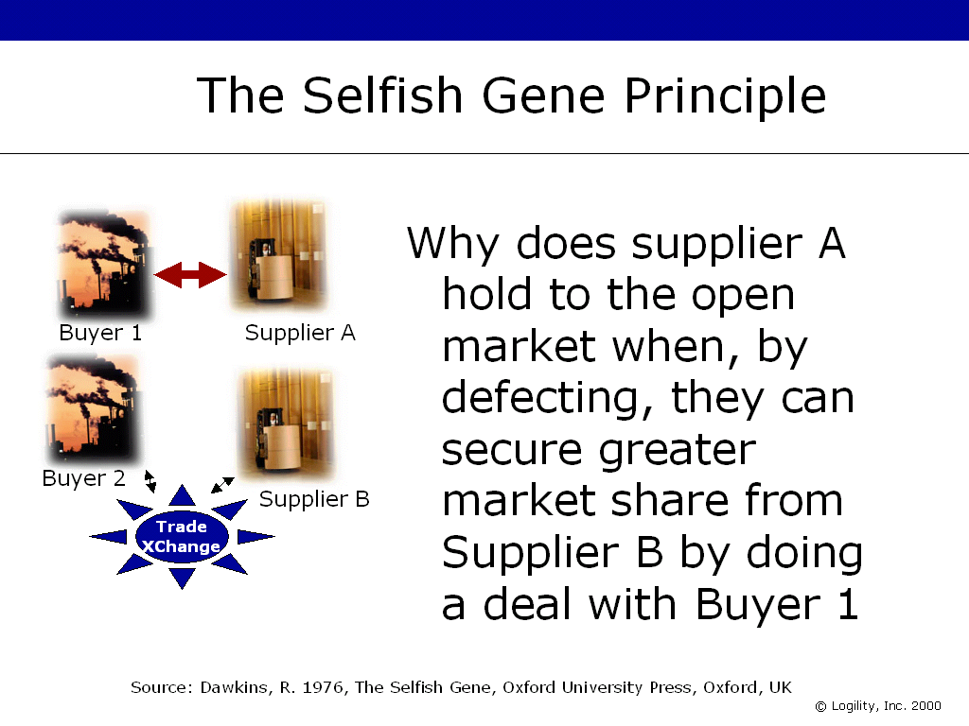
Figure 7: The Selfish Gene Principle states that genes dictate the actions of populations in order to preserve their own longevity. In business, Selfish Gene principles imply that Supplier A, under severe competitive pressures from Supplier B via a price-driven Exchange, will defect and attempt to offer a unique value proposition to the customer in order to preserve it’s longevity.

Continuous versus Discontinuous Innovation
Geoffrey Moore would call Trading Exchanges “continuous innovations” because they maintain or extend the status quo, produce tactical benefits, and leverage past investments. In light of this explanation, consider how SAP (mySAP.com), Oracle and other traditional client/server and Supply Chain Planning vendors are trying to increase their longevity through the exploitation of the status quo.

“Discontinuous innovations” typically create an environment in which competitive boundaries are re-written. A discontinuous innovation may require a large, new investment, but it also implies redundancy of old investments.

CPFR is unique in the marketplace because it provides for the benefits of discontinuous innovation at the cost of continuous innovation because back-office and front-office systems in place today can be used in CPFR. The CPFR component itself is quite new, but it changes the transaction as it moves the focus from the customer order itself to the customer and the demands made on them from their customers. CPFR, therefore, also changes the nature of the relationship. Due to these changes, CPFR represents a new business model, and that is where the discontinuity is derived.

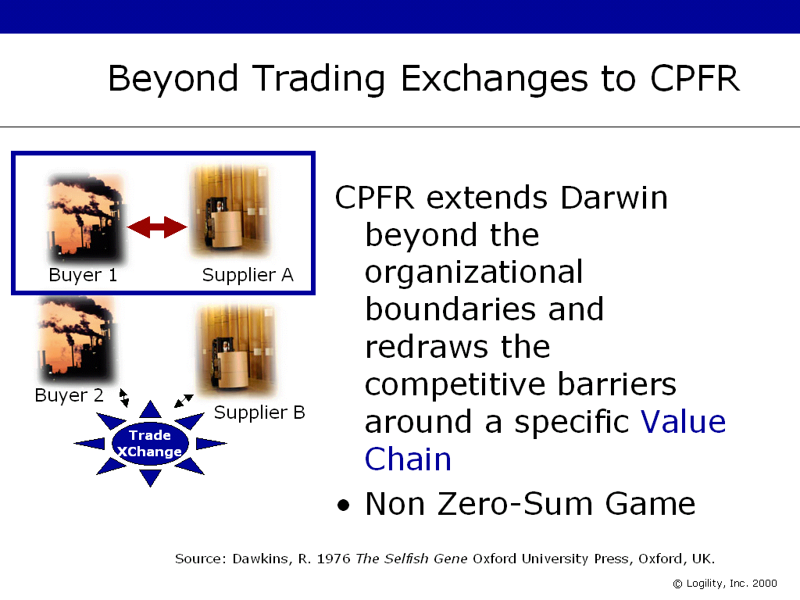
Figure 8: Defecting from Exchanges to Communities. By defecting and achieving a true Collaborative Community, Supplier A and Buyer 1 effectively create a virtual wall around themselves allowing them to compete as a Value Chain against the others left in the Exchange model.

Since Collaborative Communities have proven to be a non-zero sum game and the benefits of synergy far outweigh the short-term price benefits of an Exchange, companies like Supplier B (in Figure 8) will have to respond to the emergence of Collaborative Communities by aligning with customers in a similar fashion.

Trade Exchanges are a form of zero-sum game. 1 and 1 equals 2. Whatever I win -- you lose the same amount. There is no synergy in this model. The focus is on the transaction.

With Collaborative Communities, the focus is on the partnership and how the two companies can enjoy the synergistic fruits of aligning their people, processes and other assets. Collaboration is about developing strategies that support an “I win with my partner” rather then an “I win at the expense of my partner.” The Trading Exchange can never compete with such an adversary.

Self-Service-Based Versus Exception-Oriented
Another hangover from the old ERP and traditional client/server APS vendors is the self-service approach. This is very predictable and exploits the status quo -– as in the case of a continuous innovation. Self-service here implies the user’s ability to gain access and visibility to critical information across the value chain. This is a valuable addition to industry. But just think about it for a minute.

You place an order online for a Dell PC. This is not a very good B2B example, but it lets us ask this question: As a customer, would you go online every day to check the status of the order. I know that I wouldn’t. I have placed my order with an expectation of delivery. I assume the PC will turn up as scheduled unless otherwise instructed. If an alert notifies me of an exception and requires action on my part, then I have gone beyond self-service. In the self-service model, other parties may become involved when exceptions arise to resolve the problem before it deteriorates. These other parties could be the carrier, the shipper, the Post Office, or even Dell. This is the essence of self-service versus exception-oriented collaboration.

Trading Exchanges are self-service oriented. You have the power. And buyer beware. Some of the better Trading Exchange providers typically add some collaborative functionality to their solutions. But if they are only transaction-oriented, little value will be provided in this area; and it is likely that such Exchanges will fail at the expense of one or more of their buyers and/or sellers that support collaboration. If the Exchange is planning oriented, however, then it will have actually morphed into a Collaborative Community -- in part.

Participants Are Subservient to the Sophistication of the Software Provided
Although I have already mentioned this point several times, it has proved to be a critical factor in the early adoption of Exchanges in late 1999 and will continue to be throughout 2000. Only those companies that see through the hype and experience the Exchange in operation will realize this as a major constraint on their success. This realization will spark a new round in software application development.

These new application developments will only make matters worse because the Trading Exchange model itself is flawed. Therefore, new applications built on this model will only exacerbate the problem. Remember, it does not matter how good or flexible the Trading Exchange platform becomes, information still flows across the Exchange to competitors (who will know something is wrong with this concept as they realize how much business they stand to lose). Thus the very strength of the Exchange concept (being a common platform) is, at the same time, its fatal flaw.

For every platform that is said to be “very flexible” there will be hundreds of competitors who reinvent themselves with a view toward creating their own unique value proposition. But with everyone in the Exchange using the same software platform, support for a so-called “unique value proposition” may remain in the marketing hype -– or worse –- continually be put off until “the next release.” For it to be available to all members of the Exchange, it can no longer be a unique value proposition.

B2B versus B2C
The reason that there has been so much hype over B2B stock valuations is clear. The initial interest for Internet commerce centered on Dell and Amazon for direct delivery. These are the most overused B2C “success” stories –- however it is defined. The success of eBay spurred the use or application of Exchange models to the larger B2B market. The auction concept now inculcated in eBay is epitomized as a Trading Exchange. Therefore, Collaborative Communities focus on the B2B market.

Trading Exchange concepts make sense for B2C and commodity B2B. But only to a certain degree. Eventually, commodity pricing and margins are so eroded that no one wants to supply the product. After all, who would want to be a leader in that market space?

Internet-based Commerce Continuum

The continuum of business models that strive for press attention is shown in Figure 9.

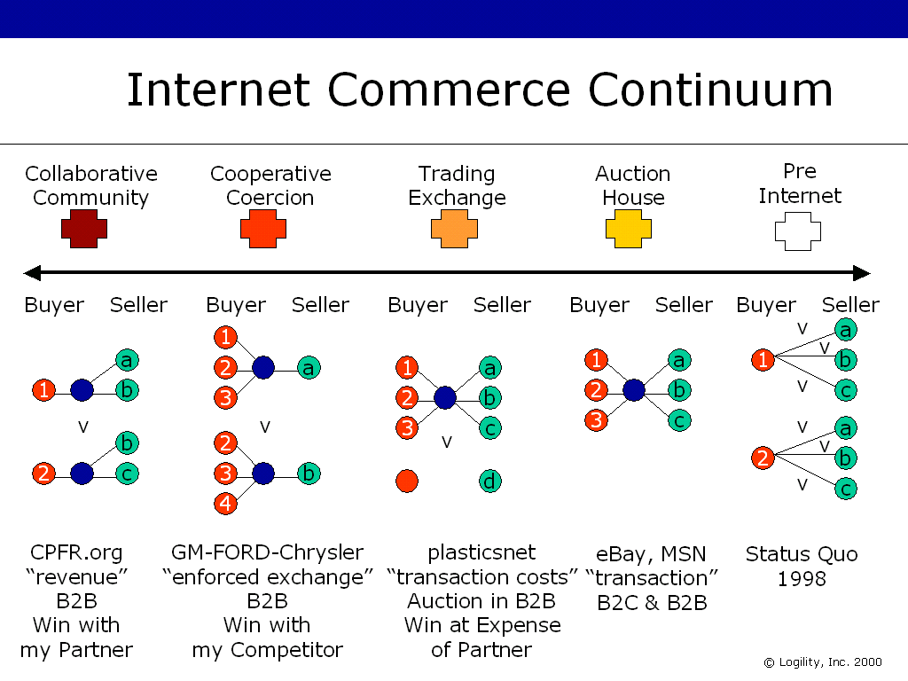

Figure 9: The Internet Commerce Continuum.
This figure shows several alternative business models that exist. The extreme models are the easiest to explain and the models in the middle are generally the “gray area” where all thinkers spend their time arguing about their vision. Collaborative Communities are about competing value chains; in Exchanges it is about traditional supply chain/demand chain.

On the extreme right of Figure 9 is the Pre-Internet era when most business focus was only on internal optimization; B2B relationships were handled on a one-on-one buyer/seller basis without any benefits or synergy being derived from pooling processes or transactions across the value chain. Today, this is a no-win situation.

The Auction House model is today the ultimate in B2C purchasing, as it provides a place where all buyers and sellers can share in technology to massively reduce the transaction costs associated with doing business with each other. This is the realm of eBay and MSN -– the place where the Internet and associated stocks received their initial impetus.

After the elimination of EDI (electronic data interchange) as a realistic tool for the Digital Economy, it is possible that the costs associated with the placing of purchase orders and customer orders will, in fact, tend to zero as a paperless environment is finally replaced with a digital environment. This is the realm of the Trading Exchange. The focus for these “many to many” models is the physical transaction –- the buyer/seller process. Upon execution of the transaction, buyer and seller go their separate ways and may never meet again. And each buyer/seller is but a click away. A customer can defect and go to another supplier with just one click. This model is characteristic of “perfect competition.” It is associated with free and available information such as pricing and availability of all alternative products so that buyers will always make rational decisions.

Trading Exchanges are the natural extension of the Auction House model in a B2B commodity world. Examples here focus on vertical industries, although a provider of the technology (the hosting service, for example) could offer many focused “hubs” -- each to a different industry.

In this model, a company plans to win at the expense of its partner.

Cooperative Coercion is a new phenomenon that may be rare, but is very powerful. It is a hybrid model that tries to marry the benefits of transaction cost reduction from the Trading Exchange model with the additional benefits of Collaborative Communities. Recently, three of the largest automobile manufacturers in the U.S. “clubbed” together (I can’t think of a better word for it) to provide a centralized hub where their joint purchasing requirements can be funneled to participating suppliers, thereby enabling access to a bulk buy. The benefits of the Trading Exchange model here are secured because the Internet is being used and the transactions themselves are all flowing through one hub, as opposed to each manufacturer building its own Exchange. Also, some amount of (true) collaboration is possible as the supplier might be able to share and “jointly derive” some planning data if it is provided by the manufacturers. However, the true benefits of a Collaborative Community are forestalled in this model by a shortsighted but powerful economic belief that cost cutting and a focus on the transaction cost is a better use of Internet technology than revenue growth and market share. The transaction costs will and are falling –- irrespective of the model used. Further, this model is still really more of a Trading Exchange as the replenishment (transaction) remains based on the self-service model.

In this model, a company might even plan to win with its competitor -- even to the detriment of the supplier. As a result, this does not appear to be a viable long-term alternative.

In the Collaborative Community a company plans to win with its partner. In essence the assumption is that a buyer can win in its market space by strategically aligning with a seller -– in effect creating a value chain battle front so that, instead of company versus company being the mantra, it is value chain versus value chain. This is an old idea, but is only operable today because of the Internet. However, (to use an overused phrase) an “out of the box” perspective is needed to grasp the full weight of this model.

The idea here is that 1 and 1 equal 3. In non-collaborative models, the idea is that 1 from 3 equals 2 -– a zero sum game. In a Collaborative Community, it is designed to be a non-zero sum game. A buyer basically picks key suppliers and tries to lock-in certain relationship components made up of products, services, etc., so that both parties share in the costs and benefits of defeat and victory. This is alien to most people and organizations, but is no different than what takes place in the animal kingdom. Sharks have their teeth cleaned by multitudes of very small fish that dart in and out of the shark’s mouth. The shark could defect and eat the cleaners and have a very nice meal (at the cleaners’ expense). However, that defection would, in the long term (a key point), cost the shark dearly as he would never then get his teeth cleaned and thus develop diseases. So he forgoes the short-term (key point!) benefits of a quick meal and leaves the cleaner fish to go about their business.

A shark that eats its teeth cleaners is the same as a business looking only at the short-term benefits of a quick deal in terms of price reduction, rather than taking a longer-term perspective and exploiting synergy between the buyer/seller systems.

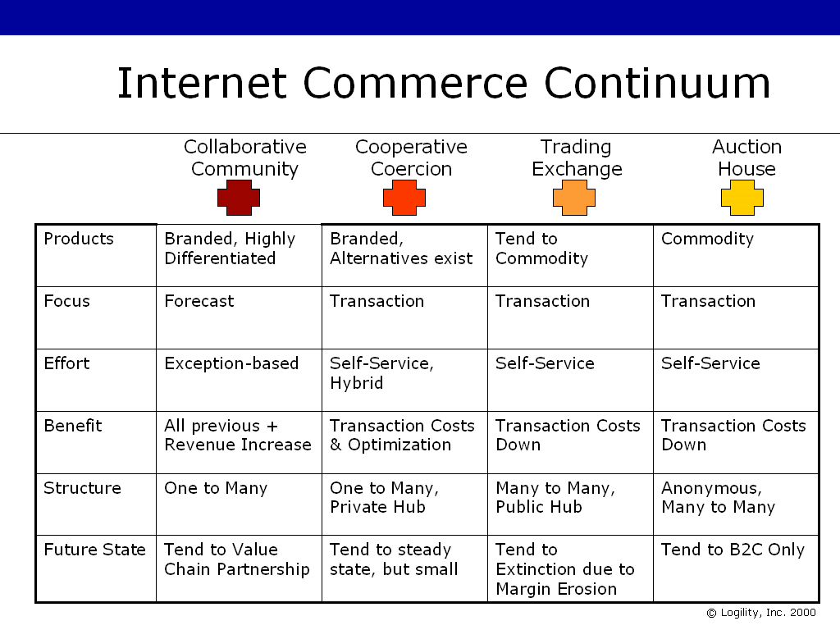
Figure 10: The Internet Commerce Continuum Summary of Key Differences.

Future of the Trading Exchange Business Model

In summary, our view is that these over-hyped environments will devolve to handle commodities, low-margin products and services, and those products/services with numerous sources of supply and generally no differentiation. In other words, they are best suited to parts of the economy that do not typically provide for significant profits, competitive opportunities, or represent large chunks of many of the mainline economic segments.

Those Exchanges that want to focus on direct material procurement and planning will have to evolve to the latest model that supports the more collaborative models described in this paper -- the best and most forward looking being Collaborative Planning, Forecasting and Replenishment, or CPFR. By offering this service for its buyers and sellers, an Exchange will provide a complete, rounded and supportable environment for the Digital Economy. The Exchange itself will grow and flourish and not be relegated to the commodity business.

This paper has described Trading Exchanges and Collaborative Communities as separate business models. It is our belief that most organizations need access to both formats. However, most technology providers call themselves “trade exchanges” or “net markets” or “digital market places,” etc. These names are unlikely to change, but the underlying models need to evolve to support Collaborative Communities in order to participate in the next phase of the B2B e-Commerce revolution.

Many Trading Exchange providers have a significant problem. They were launched on the message of a focused vertical or segmented Exchange model. Huge funds were provided to these companies since the assumption was that these models were a central part of the Digital Economy. Now, with the bubble about to burst and investors wanting a return, these companies are looking to expand in many directions. As a result, other vertical segments of industry are being sought out. Additional “value-add” products and services are also being added to widen the attractiveness of being part of the Exchange. For example, several Exchanges are moving very aggressively into “traditional” consulting for ERP and supply chain applications and even into CRM (customer relationship management) applications -–an expected move since such applications are now being hosted by these Exchanges. Additionally, and perhaps ironically, Collaborative Commerce providers are being highly sought after as a means of keeping the Exchange afloat. Many smart buyers and sellers are simply using the Exchange model as a marketing tool in order to find their customers and are actually planning to transact business in a collaborative manner once they have their prospects targeted!

Those Exchanges that secure a partnership with respect to Collaborative Commerce will probably survive. If a Collaborative Community is established of its own accord for a segment, other Trading Exchanges in the same space are likely to become second-class replenishment and fulfillment models.

Before any purists argue with any of this paper, we recognize that the goals of the Trading Exchange model are very intuitive. The concept of providing real-time availability of all information needed to assure a rational buyer/seller relationship is the goal of all that we do. However, the key point is this: The very use of a centralized, formatted, standardized platform with which to arbitrate how buyers and sellers can operate is the very flaw of the model. Since the model sets a standard by which all business is transacted through a Trading Exchange, there can be no competitive advantage among those who use the Trading Exchange. Competition between sellers is therefore rationalized and reduced to whatever the Exchange features allow. The very purpose of competition is undermined.

As pressure mounts on suppliers to conform to the Exchange rules, their autonomy is removed. Price becomes the only factor that can be effectively used to differentiate between each other’s offerings. Pressure continues on price as margins erode. It is then that a bright company with a good idea will defect. They will be highly motivated to do so as their idea is based on the principles of competitive advantage. They will attempt to bypass the slow, restrictive, non-responsive Exchange set up. They will ignore the new middleman and go straight to the customer and offer a unique offering. What a concept.

Oh I almost forget about the “shhh -– don’t tell my competitor” subhead at the beginning of this document. Imagine if you will, that you were the first company in your industry segment to spot this issue regarding the fallacy of Trading Exchanges. What benefit would you derive if you defected first and created a Collaborative Community while your competitors were left happily kicking each other apart? It’s likely that those companies that catch this wave first will reap the lion’s share of the benefits.

The moral of the story is to move now, move fast, and leave the competitors at the trough looking for the next “quick fix”.

For more information, please go to:

CPFR Web site www.cpfr.org
Logility B2B Collaborative Community (CPFR) Web site www.b2b-icommerce.com
Logility corporate Web site www.logility.com

