Digiconomy™
The Digital Economy

By Andrew G. White
Logility, Inc.

Digiconomy. The digital economy. Business enabled by the Internet, we are told day after day, "changes everything." But does it? What’s real and what’s hype about this revolution? How does the digiconomy really affect your business?

Make no mistake. The Internet does change things. But we’re just now beginning to grasp how and what those changes will mean. In some cases, the changes are not what we expected.

The most profound change the Internet has caused is not in how we conduct our business internally, but in how we relate to our trading partners and our customers. The new business model, born of the Internet, is a collaborative one. How we got to the collaborative model and what it means for business-to-business training partners is the subject of this paper.

We’ll look at the Internet-driven digiconomy from two perspectives. First, we’ll explore a number of current models; then, we’ll look more closely at how Internet-driven models will evolve and change the relationship with business trading partners and what this revolution will mean for the way business is done.

The Digiconomy Framework Part 1

The Way Things Work Now & How They Will Change

Framework 1: The Digital Economy Framework

c-Commerce
b2b-icommerce
i-Commerce
VerticalNet
e-Commerce
EAI
e-Commerce
eBay
e-Commerce
MRO
Commerce Model
Supply Chain
One to Few
Self-Service
CRM/APS
Procurement and Exchange
Value Chain
1 to 1, Joint
Exception
APS/CPFR
Collaboration
1 to 1
EDI
Integration
Supply Chain
1 to Many
Self-Service
ERP/CRM
Auction
Supply Chain
1 to Many
Self-Service
ERP/CRM
Catalog
Buyers and Sellers
Means
Business Model

ERP – Enterprise Resource Planning
CRM – Customer Relations Management
EAI – Enterprise Application Integration
CPFR™ - Collaborative Planning, Forecasting and Replenishment™ **

The chart above shows the ways in which modern businesses communicate with the members of their supply chains. All of them are Internet-enabled. Some are more efficient than others. In a sense, it is evolutionary in nature, enabling business to expand their relationships through the convergence and technology and business procedures. We feel that, in the long run, only one—collaboration—will provide the most efficient and reliable means of maintaining a competitive supply chain in the digiconomy. Let’s examine the business models so that you’ll understand more clearly why collaboration will prove the winner.

Integration: This represents the simple exchange of data between companies in the business-to-business arena. Electronic data interchange (EDI) is the typical method employed. This method, (i.e. point of sale consumption) includes the scheduled passing of customer order information electronically to a supplier by a customer. Originally the word integration was used to describe this process. Later the programs that facilitated this transfer were referred to as “middleware.” Today the process is called Enterprise Application Integration, or EAI. Today the evolutionary 'vision' in this space is running EDI over the Internet.

There is a great deal of money today flowing toward EAI vendors on the assumption that the greatest share of B2B commerce will take place over the Internet and, hence, these vendors will have a lot of opportunity. However, the fact is, this is really a very old model. It’s the same old transactions sent over the Internet. No change in the supplier/customer relationship is encouraged or enabled in this model.

Catalog: The selling point of this model is that you might already have a paper-based catalog that is always out of date and not targeted to your individual customers. Now, with the Internet, you can create an electronic version and maintain it more easily. You can even add more valuable and up-to-date information such as pricing and availability. Further, you can locate the online catalog inside your customer or prospect’s company via the Web. Lastly, you can even integrate the catalog with your order processing system so that when an approved user selects an item for purchase, the software can kick-off the necessary financial transaction in both the buyer’s and seller’s business systems. While the catalog model has its uses, it’s really just the updating of a very old model and represents no real change in the fundamental relationship between supply chain partners.

Auction: This represents the new range of Web sites dedicated to bringing together large numbers of sellers and buyers to auction off products and services. Again, this is simply what you do now—an updated version of a very old model—except that it is a more 'perfect' economic model according to classical economic theory because potential buyers have nearly immediate access to information from your competitors. The reality of this model is that your competitor is but one click away. Despite its obvious advantages to the end customer, this model, like the others we’ve explained, does not fundamentally change the way supply chain members relate to one another.

Procurement and Exchange: This represents a more recent series of supported Web sites powered by traditional ERP systems. These sites support commerce communities where buyers and sellers can find each other more easily, and, therefore, a much tighter relationship can be established. In the evolutionary process we’re describing, companies move from an open, many-to-many auction model to an environment where they reduce the supplier base somewhat in order to create a tighter relationship. This is the realm of vertical trading communities. However, procurement and exchange arrangements do not offer many opportunities to completely re-engineer the relationship between trading partners, whereas collaboration does.

Collaboration: This is the newest and most exciting development in the use and application of the Internet. Customer relationship management (CRM) software solutions and initiatives such as Collaborative Planning, Forecasting and Replenishment™ ** (CPFR)™ are changing the transaction and, hence, the nature of the relationship between trading partners. In this collaborative business model, companies realize that real, long-lasting strategic change is the route to larger benefits. The previous models do not incorporate this and, as a consequence, represent today's processes — with faster execution.

Now that we’ve explored the different business models relevant to the digiconomy, let’s look at the Digital Economy Framework again. The columns in the chart represent the different structures for doing business on the Internet.
- The Business Model names the e-commerce model.
- The Means column describes the general way in which an organization sees itself and uses technology to achieve its vision.
- The Buyers and Sellers column lists the format in which buyers and sellers come together for a given phase.
- The Commerce Model describes the technology and gives examples of the model.

** Note: Collaborative Planning, Forecasting and Replenishment and CPFR are Trademarks of the Voluntary Inter-industry Commerce Standards (VICS) organization.

True Collaboration: How It Works
As one would expect with the adoption of any new technology, there are more users of the older models and fewer early adopters of the newer ones As time goes on, more companies will learn to fully appreciate the value of the new collaborative approach to doing business.

Industry analysts have legitimized the notion of supply chain collaboration by applying their own acronyms to the processes involved. AMR Research is talking about Business Community Integration or BCI—an umbrella that covers anything that trading partners will “jointly” work on. GartnerGroup preceded AMR with its concept of Collaborative Commerce, or “cCommerce.” The GartnerGroup concept closely resembles a very precise description of true collaborative processes. The key point is that both names refer to any processes that cross boundaries where trading partners jointly produce something of value.

But both of these models were preceded by the CPFR collaborative vision. According to VICS, CPFR “is a business process model for value chain partners to coordinate plans in order to reduce variance between supply and demand.” It’s a nine-step process that helps companies realize higher service levels, higher in-stock performance, and lower inventories.

How Suppliers Benefit

Suppliers see sales increase, inventories decrease, and cycle times speed up when they use the CPFR model. This happens because the supplier gains a commitment from the customer, thereby enabling him to take advantage of a more stable demand pattern and remove much of the traditional volatility that exists in some markets today. This means the supplier can better control production and inventory, and thus, the chances of shortages or overruns are greatly reduced. The cost savings from these efficiencies can then be shared with the customer.

How Buyers Benefit

Buyers benefit from sharing the price cuts made possible by these efficiencies and from operations that are synchronized and people collaborate to develop automatic replenishment processes that eliminate costly and wasteful activities such as pricing, order promising, order tracking, and expediting. Buyers who enter into such collaborative relationships get the greatest commitment from the supplier in terms of service level and long-term price reduction in line with dual cost-cutting processes. This is not about bulk buying from several sources for price reduction. It is about hooking up two businesses in order to jointly share in the risks and the rewards of the transaction.

Where It Works Best

Today, CPFR’s strength is in the realm of consumer goods. However, organizations for other industries, such as high tech (www.rosettanet.org), retail (www.uccnet.org), and automotive (www.aiag.org), are also adopting the CPFR model. In the future, the model may even extend deeper into the execution process. Planning represents the anticipation of customer demand; execution represents the physical creation, movement, and accounting of goods. Typical planning data is a forecast; typical execution data is a customer order. If you can collaborate on a customer order and get buy-in to a value chain “one number,” then the customer order goes away (becomes automated).

Another place where the possibilities for collaboration are great is in the maintenance, repair, and operations/overhaul (MRO) space. Other than for consumables, an MRO environment could and should progress from traditional negotiations over the need for service and supplies to immediate and synchronized collaboration. As a result, pre-planned purchases will evaporate once trading partners open up their systems to each other and establish collaborative relationships.

Where CPFR Is Not Appropriate

Commodities, where price is the primary and perhaps only acquisition driver, where numerous supply alternatives exist, are not a good fit for CPFR. Those who use forward buying are not good prospects for CPFR, although it is a good target for the auction/exchange model. Users should realize that forward buying is not a solution, but a symptom of a very old problem—bad planning. By realigning companies from discrete demand/supply chains to a value chain, forward buying can and will be eliminated.

How Prices Are Set

Auction and exchange models promote “perfect information” according to classical economic theory by presenting the buyer with a number of competitive offers. The Internet brings this theoretical model closer to reality. Visualize, for example, a consumer at a store about to select a product for purchase when his or her personal digital assistant connected to the Internet sends a notice that the same product can be purchased elsewhere at a lower price. This technology means that buyers can obtain access to all—or at least a great deal more—of the buying information necessary to make a rational decision (at a fraction of the historical cost). The auction and exchange models provide this additional information in the business-to-business space as well.

Pricing under the CPFR model works very differently. In the case of established, collaborative relationships, pricing becomes a process rather then a barrier or phase in negotiation between two companies with disparate economic models on different cycles. CPFR connects the companies and establishes a common foothold for both to achieve their goals. The commitment made through CPFR ensures that pricing is a give-and-take process that evenly shares the rewards and risks of the transaction. Pricing is agreed upon periodically on a collaborative basis, and not part of the ongoing day-to-day buyer and seller negotiation.

Buyers = Sellers?

CPFR is not unidirectional. It operates between buyers and sellers in both directions. A seller can, in his or her turn, be a buyer from someone else. Therefore CPFR lives between retailers, distributors, wholesalers, manufacturers, and raw material suppliers.

Key Challenges

The primary challenge of the CPFR model is a “people” issue. Auction and exchange over the Internet is the epitome of a formal economic and industrial model – only now it is faster and more self-service oriented. Today the auction and exchange models are, and will remain for the time being, dominant in the Digiconomy as more buyers and sellers feel comfortable in an Internet-based model that closely resembles what they always wanted to do before the Internet. CPFR, on the other hand, moves the buyer/seller relationship to another level. Exchanges and auctions create an efficient supply chain; CPFR creates an effective value chain!

The collaborative model, despite the use of the word in the auction and exchange mediums, will not be the dominant model for some time. It will be the preferred route only for innovators and early adopters over the next 12 months, before moving into the early majority phase.

The Digiconomy Framework Part 2

So far, we have been talking about various Internet-enabled business models. We might even call this a macro-economic e-business framework. Now we will look at some of the same issues from a micro-economic perspective—how real constraints related to real products and real transactions play out in this new economy. In the end we will demonstrate why collaboration is the most efficient model on this level as well.

The two themes of product life cycle and business systems integration converge on the point of collaboration because, whatever the stage of the product life cycle, all three business communications models are applicable in varying levels of detail. For test marketing, exchange and collaboration are key; in product launch, the same is true; for a mature product, where more complexities of replenishment exist, all three are needed with a greater focus on collaboration; for product phase-out, exchange fits less and collaboration is again key.

Framework 2: Product Life Cycle Planning & Information Exchange Models

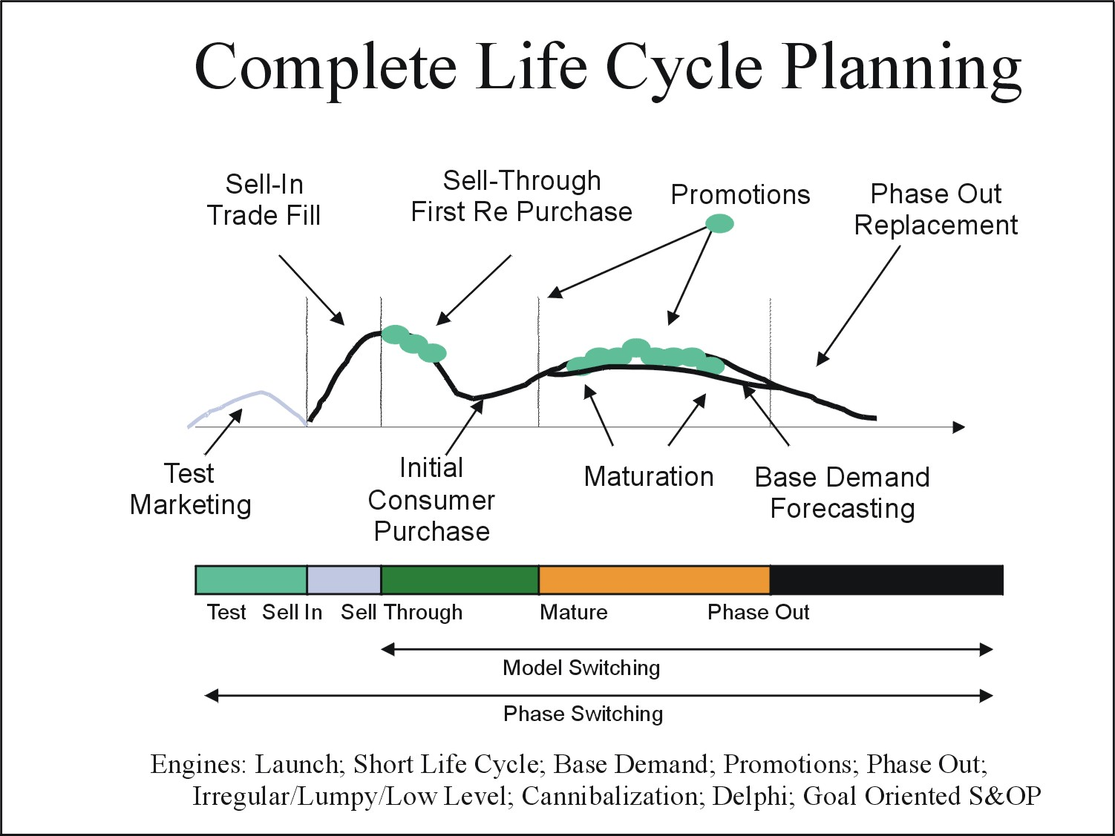

Product Life Cycle and Business System Integration

Using the figure above, we will discuss two key themes and how they intersect. The first theme is that of “stages” in a product’s selling life. Most companies that have products to sell understand, or at least experience, the fundamental issues associated with a traditional life cycle. The demands placed on suppliers, manufacturers, and customers at every phase of the product sales life cycle are different. Successful fulfillment of orders depends on being aware of what these demands are, how they are changing, and what effect the changes will have on the manufacturer’s production plans. Despite the fact that these issues rest on well-worn ground, few companies approach the optimization of the product life cycle in a similar manner. Often times companies apply systematic approaches to break the problem into smaller subsets; then they acquire or build focused tools to optimize the exchange of information and plans in those local areas. The result is a series of discrete, optimized areas that, taken together, result in an un-optimized life cycle. A more systemic approach is needed that considers the entire life cycle of the product as a whole.

Integration
Collaboration

Collaborate

Jointly Derive Data

Exchange

Send and Receive Data

Integration
Process Synchronization Across Trading Boundaries Like VMI -
Vendor managed inventory

Exchange

Underlying the product life cycle management process are the business-to-business information exchange models in use today (See pie chart). These three models are exchange, integration, and collaboration. Note that in the following discussion, the terms “integration” and “exchange” have subtly different meanings than they did in the previous discussion.

Exchange Companies have spent the last 15 years and millions and millions of dollars focused on the physical creation, movement, and accounting of goods and information about those goods as they move through the supply chain. Consequently, until recently, “best practice” was all about using EDI or some other efficient model to send and receive vast amounts of business data—typically customer orders or purchase order information—to a trading partner. Great savings were achieved by doing this, primarily by eliminating paper and labor. This exchange, the sending and receiving of data—is synchronous in nature. It flows in one direction at a time. Optimization involves making the exchange of information take place automatically between computers at the supplier and the manufacturer or customer.

Integration is an extension to exchange that came about around 1992 when Kurt Salmon introduced to the open market the concept of Vendor Managed Inventory. Today the process of automating the replenishment between trading partners goes by other names depending on the industry. In the grocery space, it is called Efficient Replenishment which itself is part of a wider initiative called Efficient Consumer Response. Quick Response (QR), Continuous Replenishment Planning (CRP), Retailer Managed Replenishment (RMR), Co-managed Inventory and others are examples.

Integration here represents the automatic and synchronous behavior between two computer systems—those of a buyer and a seller. Ideally, a buyer uses exchange to automatically send some useful data (such as shipments, POS sales) to the seller, who, in turn, automatically calculates a shipment order to the buyer location (store). This is the essence of VMI. Unfortunately, it requires EDI as the vehicle to handle the huge volume of data transfer (exchange) between partners. Because EDI is so expensive, it is only in use at the largest companies. Even today some reports suggest that less than 3% of companies worldwide use EDI.

Other than the EDI requirement, VMI and its sisters have other drawbacks that, at the time of their inception, appeared as non-issues because the technology was not sufficiently evolved. Now they have become real problems. One of these problems is the lag associated with the batch transfer of data in VMI. Now that we’re all working on “Internet time,” that time lag is unacceptable. Other problems occur in the area of exceptions, where VMI breaks down. And on the supply side, the inability to deliver is not communicated early enough to prevent poor performance. Finally, the relationship between trading partners in this system is far from being equal. Often times the seller does more of the work and ends up absorbing the buyer’s excess inventory—a boon for the buyer, but a real disadvantage for the seller.

Collaboration on the other hand, is all about jointly deriving data. For example, if both buyer and seller jointly work on the seller’s sales forecast, and they both agree to build business plans around it, and the buyer plans to deliver product to meet that plan, then the resulting “one number” becomes a contract between the two companies. Gone are the short-term, disruptive promotional issues; up goes the service level at the customer location; down goes the inventory, and so on. The point is that jointly deriving the data and committing to acting on it is vastly different than anything tried previously. Lip service has been given readily to the term partnership, but only when this partnership becomes a financial arrangement where risk and reward are shared is it likely to succeed.

What is the result of such collaboration? The customer’s customers are more likely to get the service they desire. This is the end game. Collaboration provides a process to any company that, if adopted, will assure a higher level of customer service to its customers’ customers.

Summary

The question is no longer “how viable is collaboration?” Now it’s “who can best use collaboration?” Looking at the two digiconomy frameworks, it is easy to see. Every company that buys or sells a product on a periodic basis has a choice. They can build their customer service model on a traditional, self-service model that today, with the Internet, offers incremental (perhaps evolutionary) benefit over current business models; or they can replace those outdated models completely and aim for change or revolutionary benefits by going for a collaborative model.

But beware. The word “collaboration” is now sometimes offered as the password to Utopia. Software application vendors, EAI vendors, system integrators, consultants, and e-commerce service providers of every stripe market their products as “collaborative” solutions. Not all of them are. In fact, many are simply Internet-enabled versions of old business models. Caveat emptor!

